Physical Science  Team Target  Mrs. Belveal  Room 814  heather.belveal@jcschools.us  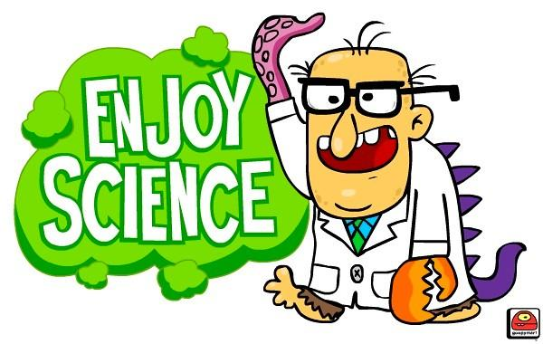 | Lab Safety Contract  All students will be responsible for:  - Reading and understanding the lab safety contract.  - Signing the contract and getting their parent/guardian's signature on the contract.    - All students must pass the lab safety quiz with 95% accuracy. | In this class:  - We will learn about the world around us, by studying units on:  - Matter (50 day unit)  - Energy (30 day unit)  - Waves (21 day unit)  - Force and Motion (60 day unit)  - We respect learning, our peers, and ourselves.  - We work together to learn how to positively communicate and get along, as well as grow and become independent learners.  - Chromebooks will be placed in an assigned drawer when students come into class and all notes will be taken on paper.  - This is more of a hands on class and the Chromebooks will be used but it will be sporadically (mostly for testing, research and virtual labs).

Grading policy:  60%- test/quizzes  30%-course work  10%-finals  There will be 3 grades a week. The warm-up grade will be a cumulative of the week (these questions will be a review of 6th and 7th grade curriculum).  Late work policy:  - All homework MUST be turned in by the end of the month it was assigned in or it is a zero in the grade book.  - There is no Extra Credit at LCMS so please don’t ask for it.  - There will be an email sent out every 2 weeks for any missing work. | Behavioral Plan:  No matter the infringement, breaking a rule is subject to the following.  - A polite warning to get back on task.  - Moving to the safe seat. If that doesn’t work...then  - Moving to the buddy room and filling out a think sheet.  - Contact to parent/guardian.  - Written referral if the behavior persists or if the infraction is severe enough to skip the previous steps.  Behavior  Intervention  Support  Team | Class Reminders  - Have a pencil!  - Have your id with you everyday, please.  - No Cellphones  - No bags in class  - No food in class!!!  - Water must be in a clear bottle and NO SHARING!!  - Throw gum away in trash...if any is found stuck anywhere in the room NO GUM will be allowed in class!!  - All work will be done during class periods…..there will be no work taken home.

